1, SYSTEM RECOVERY THE PRECISE IMPORT IAR DRIVE EXAMPLE
When to use:
The target computer -> boot -> enter the BIOS - adjust the disk controller mode (AHCI) -> Restart -> into PE -> restore the system to a system disk (for example, C: \) -> use SkyIAR -> reboot -> system deployment began
Using the premise:
Restore the system image does not contain other disk controller driver
How to use:
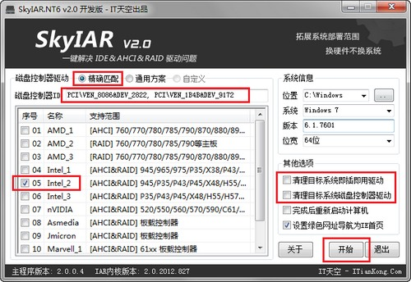
(1) select the "exact match" mode (the default)
(2) SkyIAR automatically detects disk controller hardware ID and system type
(3) SkyIAR match automatically depending on the type of disk controller hardware ID and system radio drive
(4) If the recovered image does not contain other IAR drive (recommended state), and do not need to tap two clean-up projects
(5) If the recovery image is included the other IAR drive (not recommended state could easily lead to the driver conflicts), try to click on the "clean up target system disk controllers drive
(6) Click the "Start" button, and automatically import start
2, SYSTEM PACKAGE AFTER SETS IMPORT THE IAR-DRIVEN PARADIGM
When to use:
Completion of the system packaging -> Restart the computer -> into the PE environment -> SkyIAR -> system image backup system
Using the premise:
System is executed the package operation system (not recommended for direct cloning of any non-encapsulated)
How to use:
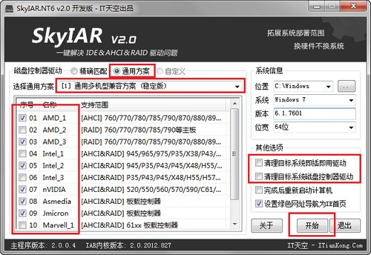
(1) "universal program" mode is selected
(2) SkyIAR system will automatically detect the type of
(3) SkyIAR provide suitable drive according to the type of system
(4) Click the universal solution, SkyIAR will automatically select the driver program project
(5) Package deleted Plug and Play drivers and non-secondary package (recommended by the state), and do not need to click on two clean-up projects
(6) package not remove the plug-and-play drive or secondary package state (not recommended), you need to click on the appropriate cleanup project
(7) Click the "Start" button, and automatically import start
3, REPLACE HARDWARE WITHOUT REPLACEMENT SYSTEM EXAMPLE
When to use:
Computer starts after replacing hardware -> enter the BIOS -> to adjust disk controller mode (AHCI) -> Restart -> into PE -> use SkyIAR -> reboot into the system
Conditions of Use:
Hardware platform differences before and after the replacement is not too great, and no significant difference between the hard disk read and write mechanism
How to use:
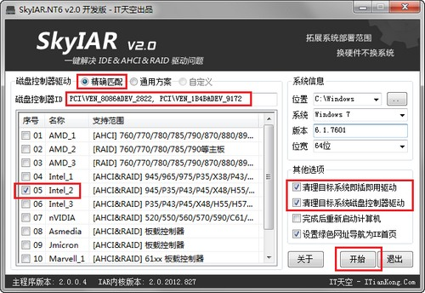
(1) select the "exact match" mode (the default)
(2) SkyIAR automatically detects disk controller hardware ID and system type
(3) SkyIAR match automatically depending on the type of disk controller hardware ID and system radio drive
(4) Click the two clean-up projects
(7) Click the "Start" button, and automatically import start

4, Change The Current Disk Controller Mode Without Reloading System Example
When to use:
Computer starts -> enter the BIOS -> to adjust disk controller mode (AHCI) -> Restart -> into PE -> use SkyIAR -> reboot into the system
Conditions of Use:
Generally used for IDE mode to AHCI mode
How to use:
(1) select the "exact match" mode (the default)
(2) SkyIAR automatically detects disk controller hardware ID and system type
(3) SkyIAR match automatically depending on the type of disk controller hardware ID and system radio drive
(4) Since only replace the disk controller mode, generally do not need to clean up the disk controller drive
(5) If you do not clean up the current disk controller driver into the system not work, try to select the cleanup
(6) Click the "Start" button, and automatically import start

